THE UNITING CHURCH IN AUSTRALIA
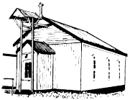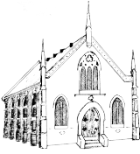
St Leonards Portarlington Drysdale

CELTIC FESTIVAL
Queenscliff Uniting Church
4.00 pm Saturday 10 June
Izzy Losi and the Auracles
Izzy has one of the most powerful voices, rich, complex and pulsating with warm keys and lilting guitar, it’s sexy and soulful and it’s Australian!

MUSICAL BANQUET
With Digby Hannah, Song-writer
5.00 pm Sunday 18 June
Wesley Church
BYO food to share
100 Yarra Street Geelong
Ring 5229 8866 for more information


Thought for the day

The best and sweetest things in life are the things you cannot buy:
the music of the birds at dawn,
the rainbow in the sky,
the dazzling magic of the stars,
the miracle of light,
the precious gifts of health and strength, of hearing, speech and sight,
the peace of mind that crowns a busy life of work well done,
a faith in God that deepens as you face the setting sun,
the boon of love,
the joy of friendship.
As years go by, you find the greatest blessings are the things you cannot buy.

Patience Strong
ROSTERS 18 June

Portarlington

Managers: Graham & Brenda Vohmann
Morning Tea: David & Lorraine Hughes & Shirley Logan
Pastoral Care: Geoff Pryor
Prayers: Geoff Pryor
Reader: Pammi Pryor
PowerPoint: Joan Kelly
Lawn Roster: 19-23 June
Robert & Wendy Sharp & Jan Hall

Drysdale

Worship @ 9
Kitchen: Wayne's Team
Counting: Margo Jones

10. 45 am
Duty Elder: Jen Davis
Prayers: Jenni's Team
Readings: Jenni's Team
Welcome: Margaret MacGillivray
Morning Tea: Marguerite Edgar & Alma Milvain
Flowers: Merrilyn Lloyd
Counting: Harvey & Jen Davis
Food bank: Margo Jones

St Leonards

Welcome: Margo Jones
Readings: Kay Baulch
Prayers: Marj Wilson
Flowers & Brass: Geoff & Sandra Giddings

News Sheet: Norm Cheale

Trinity Sunday Sunday, 11 June 2017
Trinitarian theology shows that the nature of God is relational and communal. In relationship we live and move and have our being with God and with one another. But, because the Christian Trinity is a fourth-century construct, we should not expect these texts to illuminate Trinitarian theology. We can, however, use Trinitarian theology as a lens to view these texts. While the first creation story focuses on the goodness of creation, it begins with God (v.1), Spirit (v.2) and word (v.3) and ends with God creating human beings in God’s (“Our”) likeness. The Psalmist continues with the blessings of creation. The letter to Corinth speaks of the grace of Christ, the love of God and the communion of the Holy Spirit. Finally, Matthew’s Gospel issues Christ’s great commission: to make disciples of all nations and to baptise in the name of the Father, Son, and Holy Spirit.
Abingdon Worship Annual

Source eg Abingdon Worship Annual
Minister: Rev. Temukisa Amituana'i-Vaeluaga
Email: temukisa.av@gmail.com
Mobile: 0400 664 991

CHURCH OFFICE: Drysdale Church Centre
Phone: 5253 1336
Email: drysdaleuc@yahoo.com.au
Web http://drysdale.unitingchurch.org.au

UNITINGCARE OPSHOP: Village Walk Drysdale
Phone: 5251 3640
LECTIONARY
11 June Genesis 1:1 - 2:4a Psalm 8
Trinity Sunday 2 Corinthians 13: 11-13 Matthew 28: 16-20

18 June Genesis 18: 1-15 (Genesis 21: 1-7)
Pentecost 2 Psalm 116: 1-2, 12-19 Romans 5: 1-8 Matthew 9:35 - 10:8
(Matthew 10: 9-23)
THIS WEEK IN OUR CONGREGATIONS:
Sunday 11 June, CELTIC FESTIVAL
Portarlington
9.00 am Rev. Temukisa &
Rev. Dr Peter Blackwood
Drysdale
9.00 am Worship @ 9, Wayne's Team
10.45 am Rev. David Walker
Loose change & food bank at both services
5.00 pm Messy Church
St Leonards
5.00 pm Anglican led

Monday 12 June
Queens Birthday

Wednesday 14 June
9.30 am Drysdale, mainly music

Thursday 15 June
9.00 am Portarlington, Choir practice
9.30 am Drysdale, Choir practice
10.30 am Drysdale, Coffee & Chat, Cafe Zoo
11.00 am Arcare, Portarlington Chapel

Friday 16 June
9.15 am Drysdale, Friday School

Saturday 17 June
8.00 am Drysdale, Prayer Breakfast, Cafe Zoo

Sunday 18 June
Portarlington
9.00 am Rev. Temukisa
Loose change & food bank
Drysdale
9.00 am Worship @ 9, Jenni's Team
10.45 am Jenni's Team
St Leonards
5.00 pm Rev. Temukisa

ALL CONGREGATIONS

News from Synod
About Face
About FACE (Faith & Cultural Exchange) runs in partnership with UAICC (Uniting Aboriginal and Islander Christian Congress) and celebrates the covenant relationship between UCA and UAICC.
The next program runs from 24 June to
8 July 2017 and is open to all over 18 years of age. It will include a period living in UAICC communities.
For more information and to receive program updates, visit the website and sign up to About FACE or email Jill at info@aboutface.org.au.

Safe Church Training
Safe Church training will be conducted by Rev Temukisa on Thursday 15 June commencing at 7pm at Portarlington.
The training is for people interested in knowing how we make the church a safe place for all. Everyone in a leader role is particularly asked to attend.

Electrical Appliances
If you have any broken or unwanted small electrical appliances they are being sought by an after school care group who have fun pulling them apart.
Contact Koren 0408618784.

DRYSDALE

Privacy
We remind all members of the congregation that the contact details of members included in the Directory are for personal use only and are not to be given to any other person. We respect people's privacy and intend the Directory to be used for pastoral contact by members only. Thank you for your cooperation.

Pews For Sale
There are 3 small pews available for sale. Each have only the left hand end. Price is $130 each. Cushion included. Purchase can be arranged with Ian McLaverty or Wayne Myers.

Messy Church
Today is Messy Church. The theme is Women of the Bible. Come along, bring a friend, do some crafts, discuss some questions, join in the celebration service, and share in the meal.

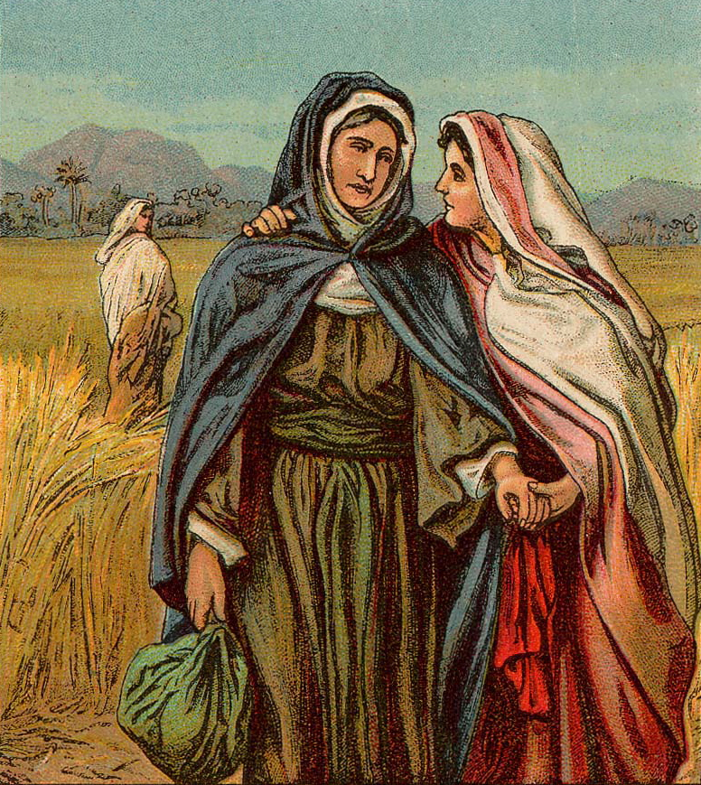
PORTARLINGTON

Fellowship Breakfast.
Saturday, 17 June 2017

Please note the June meeting will be the third Saturday this month, so as not to clash with the Celtic Festival.

The guest speaker will be Associate Professor Libby Porter (daughter of Ian & Joy) . Libby is a Vice Chancellor's Principal Research Fellow (RMIT) where she leads research on the politics of urban land, property rights and dispossession.

Libby will bring insights into the untold injustice in Israel-Palestine and the Bedouin struggle for their land. Libby writes: “While the story of Palestinian injustice in Israel is rightly well known, much less well understood is the extraordinary story of the Bedouins. Displaced from their land during the Naqba and dispersed across the Negev desert, Bedouin communities live under daily threat of their homes being demolished by Israel to make way for more Jewish settlements.

This presentation will tell the story of the Bedouin people struggling for their homes and their lives in the Negev.” Libby visited the Bedouin in late 2016.

All members of the Linked Congregations and their friends are warmly invited to attend. Acceptances please to Barry Ruler on 5259 3304 by Thursday evening 15th June 2017.

